**Assignment 1**

**Problem Statement:** Create an AWS account and configure a budget **Solution:**

**1.Create AWS Account**

**Step 1.1:** Go to your preferred web browser and search  [**https://aws.amazon.com/**](https://aws.amazon.com/) to create an account

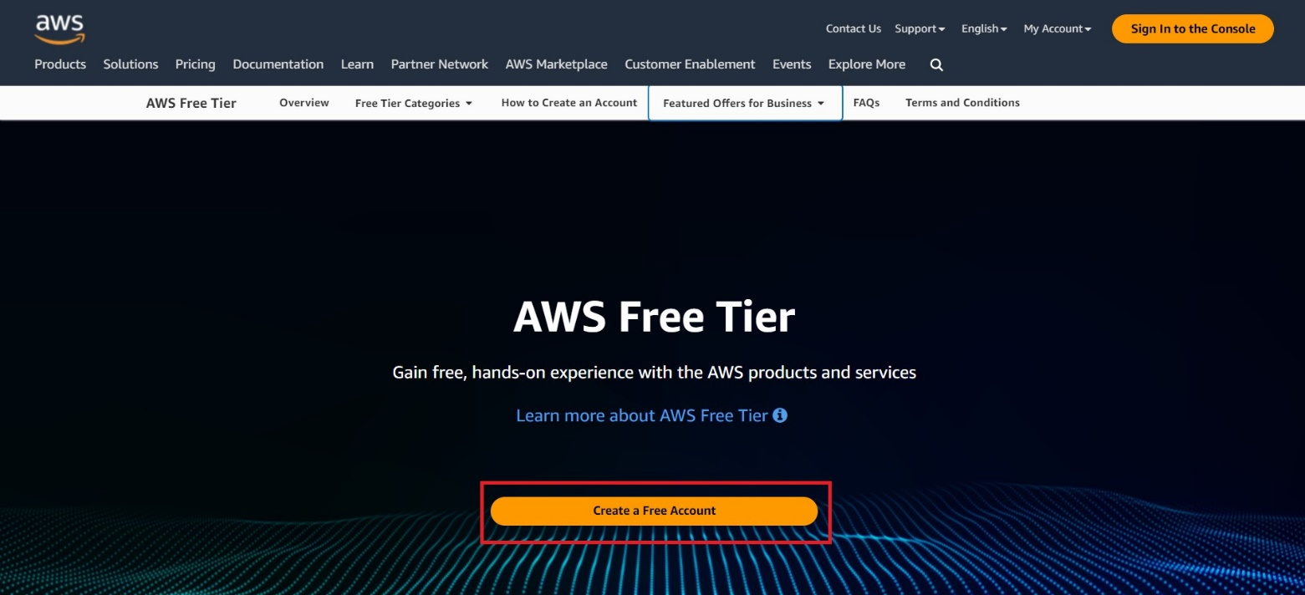

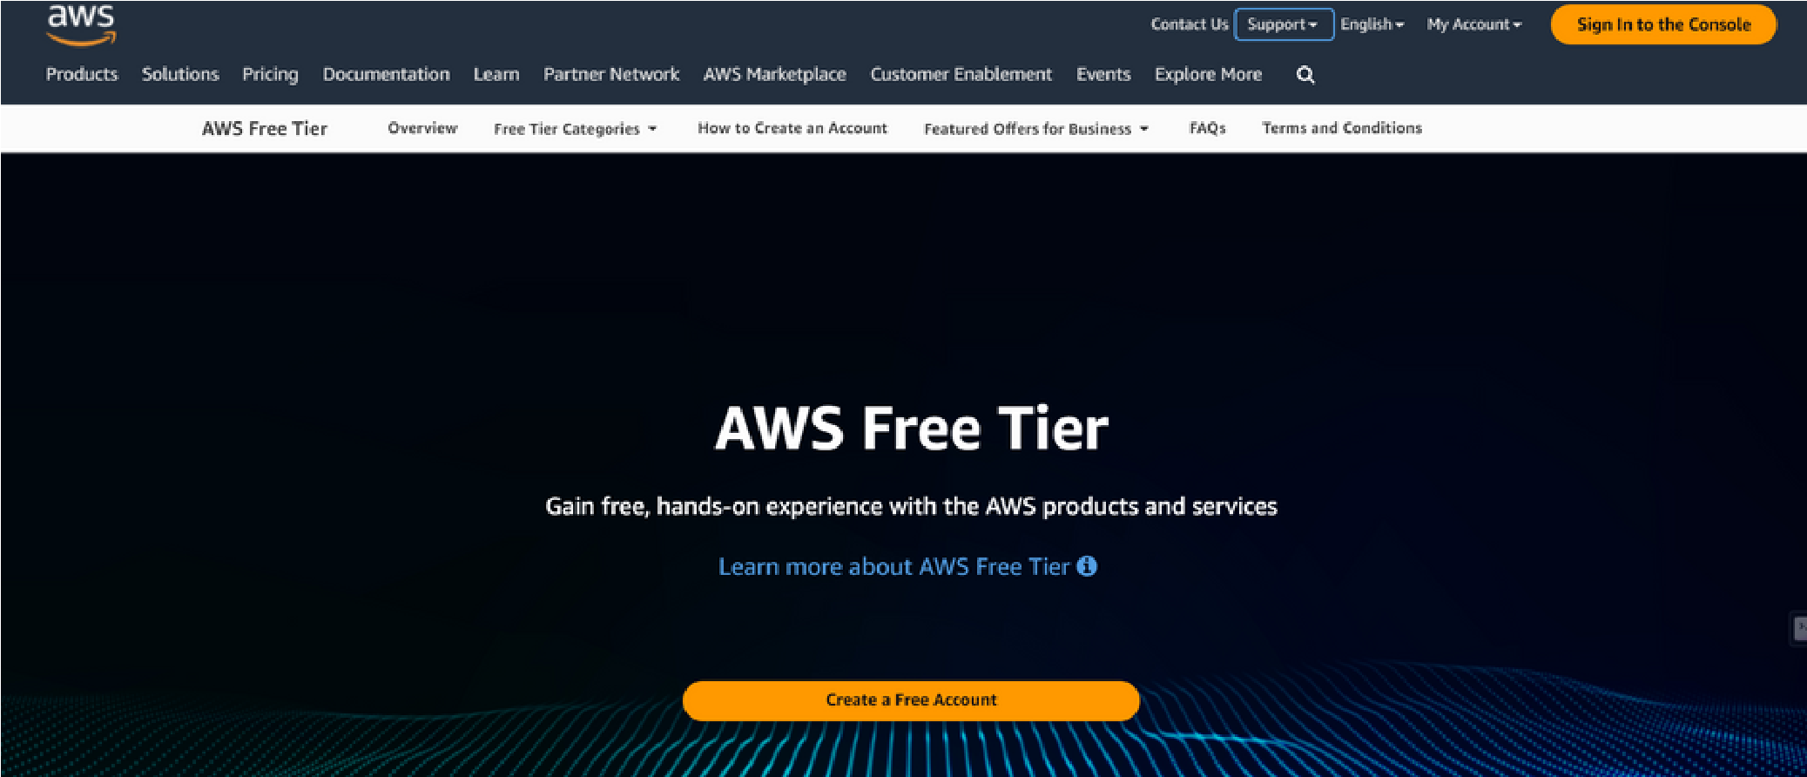

**Step 1.2:**

Choose

**Create an AWS Account**

**Step 1.3:** Enter an **email address** and an **account name,** then verify your email address by the verification code you received through your email

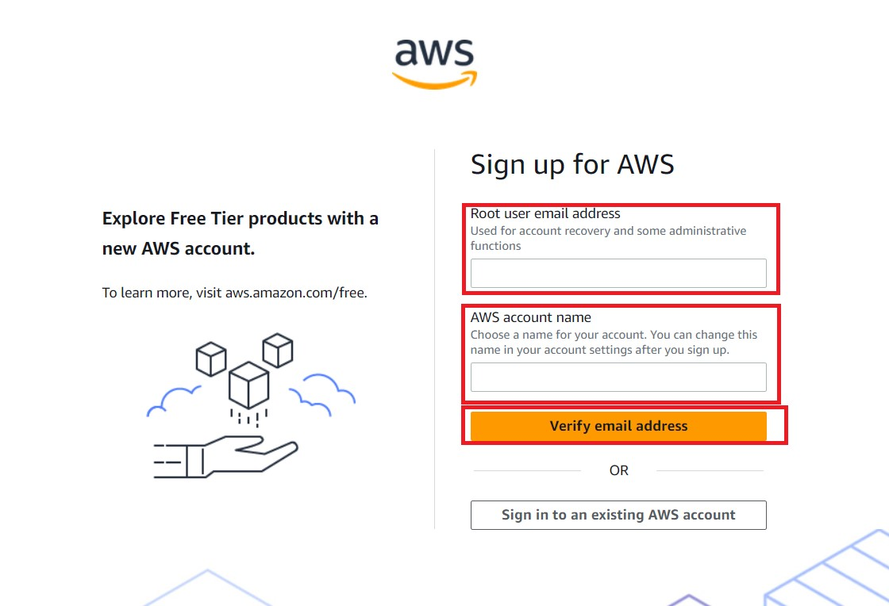

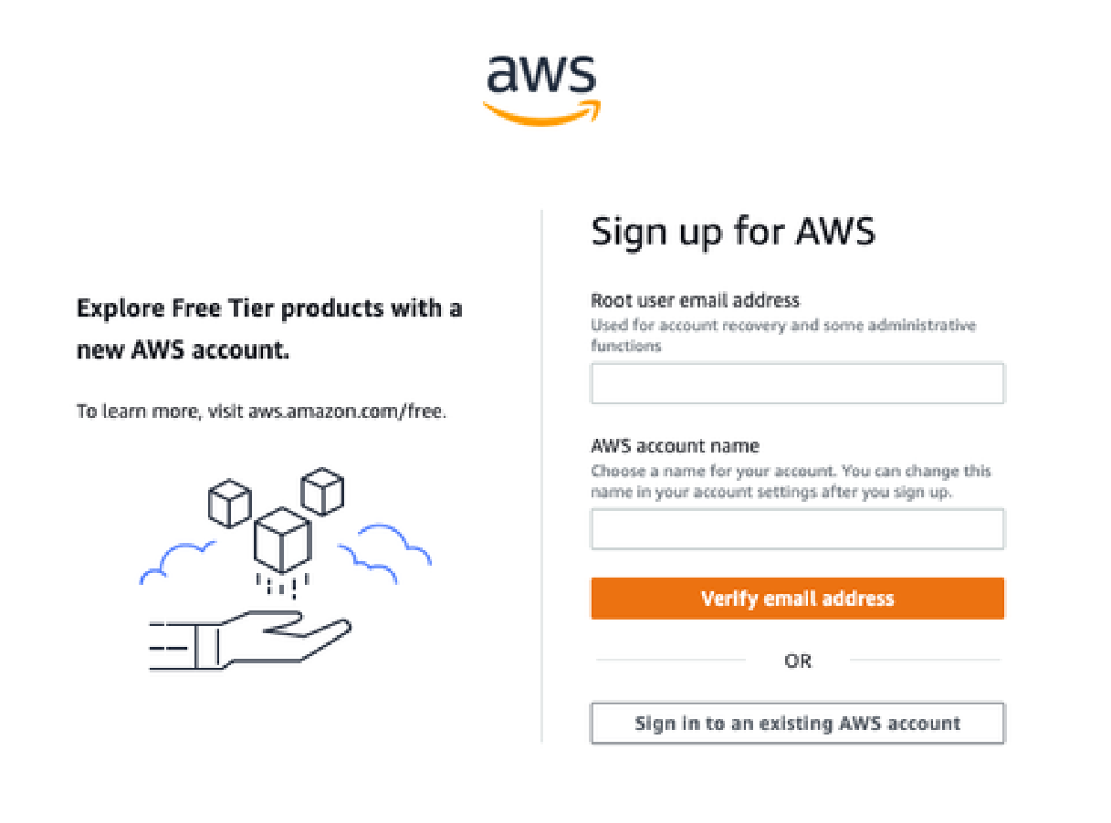

**Step 1.4:** Create your **root user password**

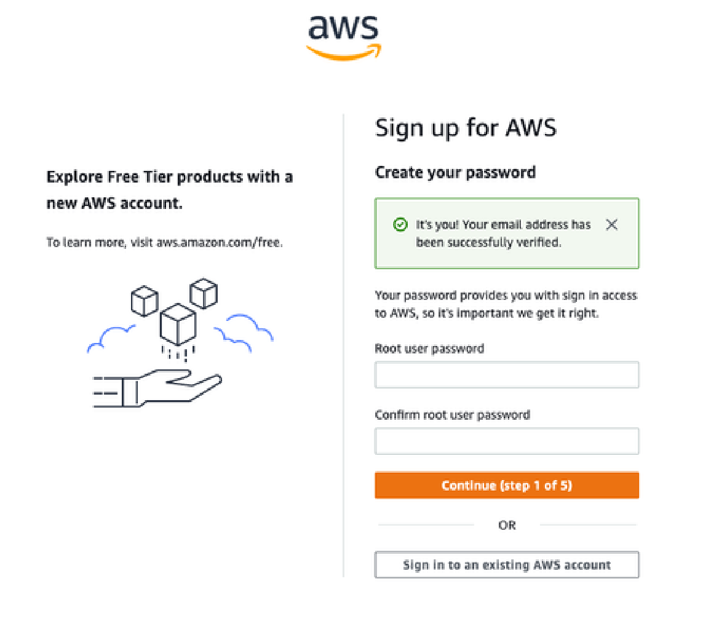

**Step 1.5:** Choose between a **business** or **persona**l account and your **billing details**

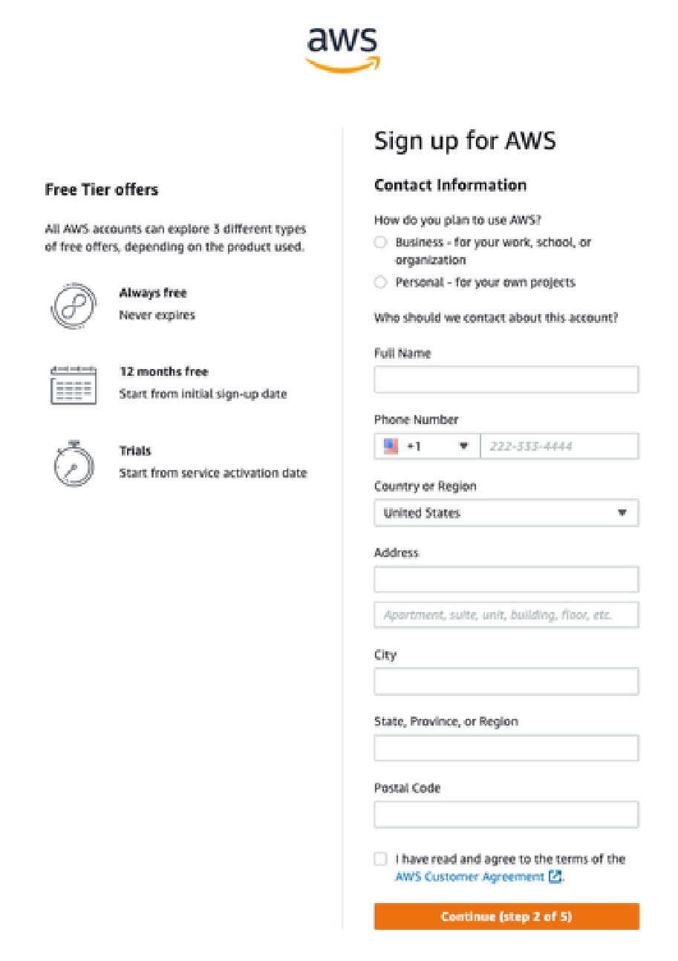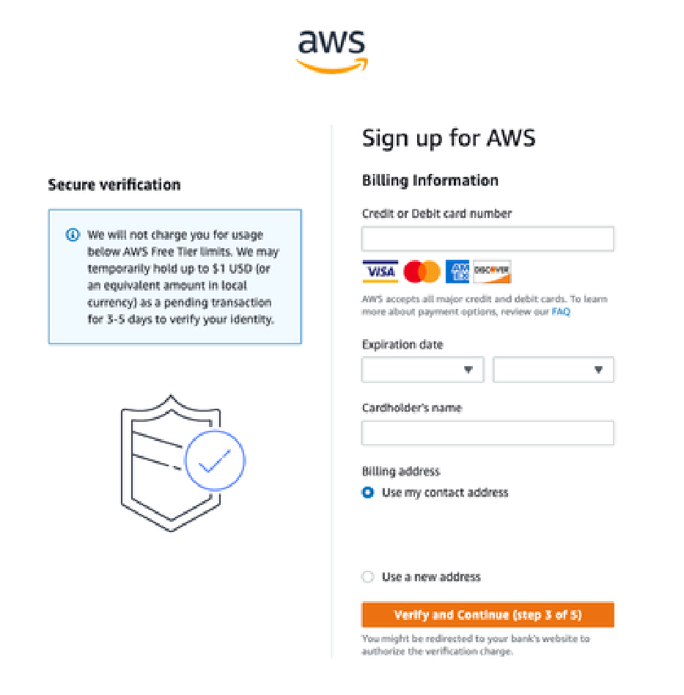

**Step 1.6:** Choose how you want to **confirm your identity** and choose **Basic support - Free** to create a **Free AWS account**

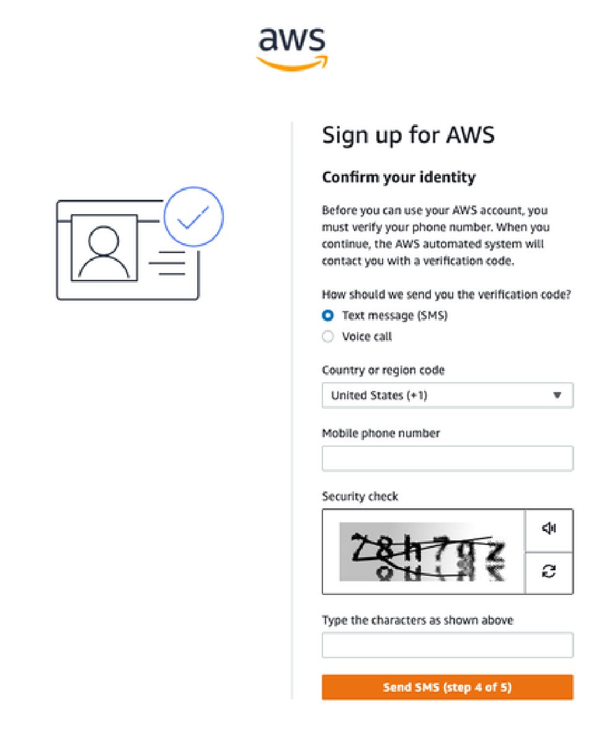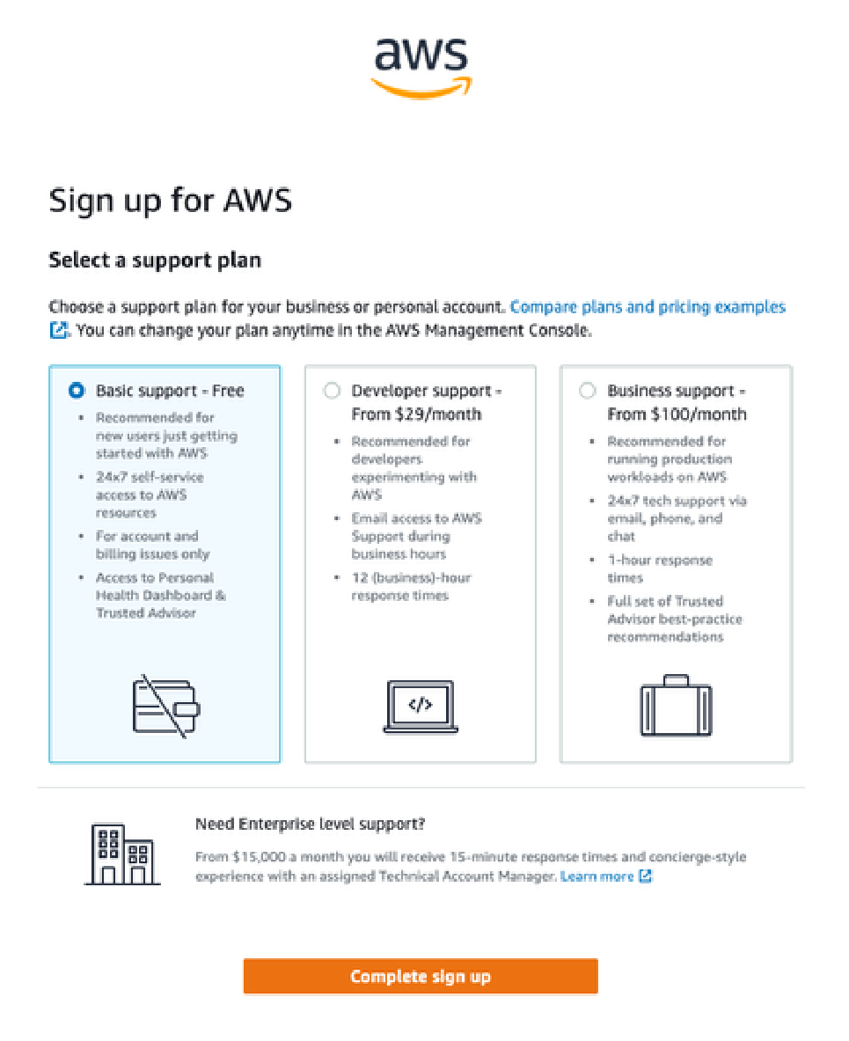

**2. Configure Budget**

***AWS Budgets is the simplest way to monitor your AWS spend and be alerted when you exceed or are forecasted to exceed your desired spending limit.***

**Step 2.1:** Open your **AWS Console,** click on **your account** and click on **Billing and Cost Management**

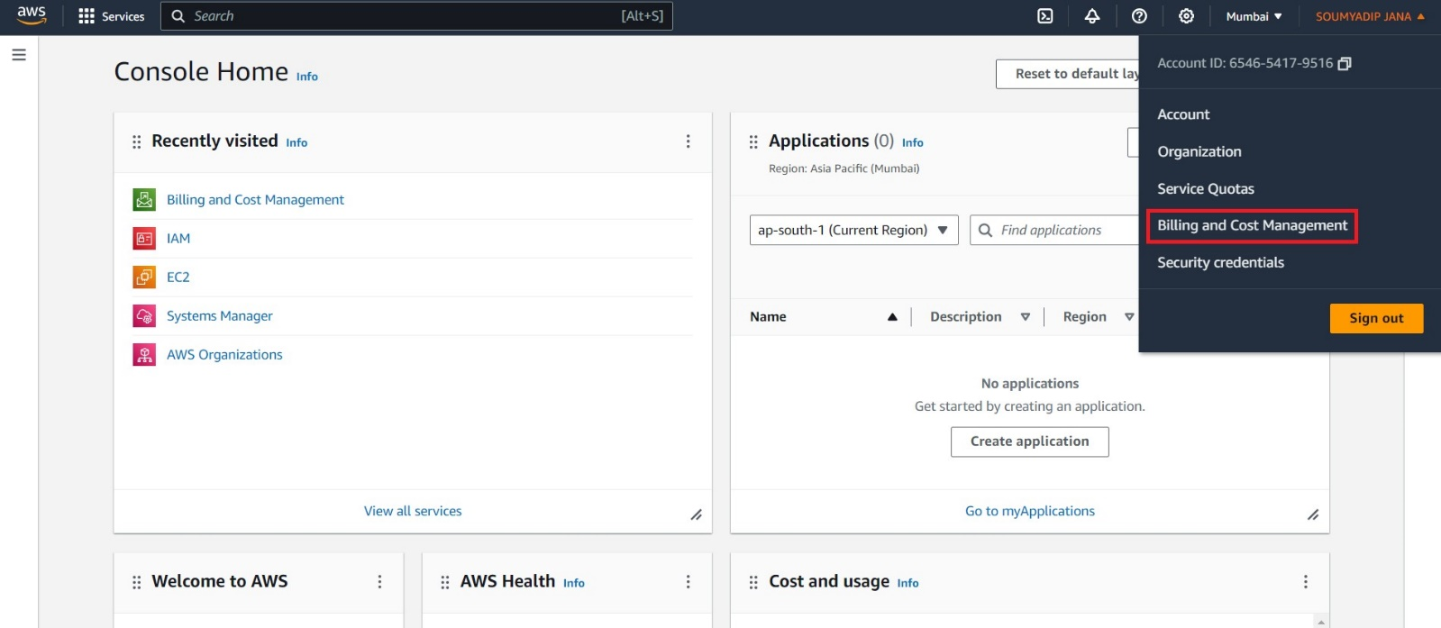

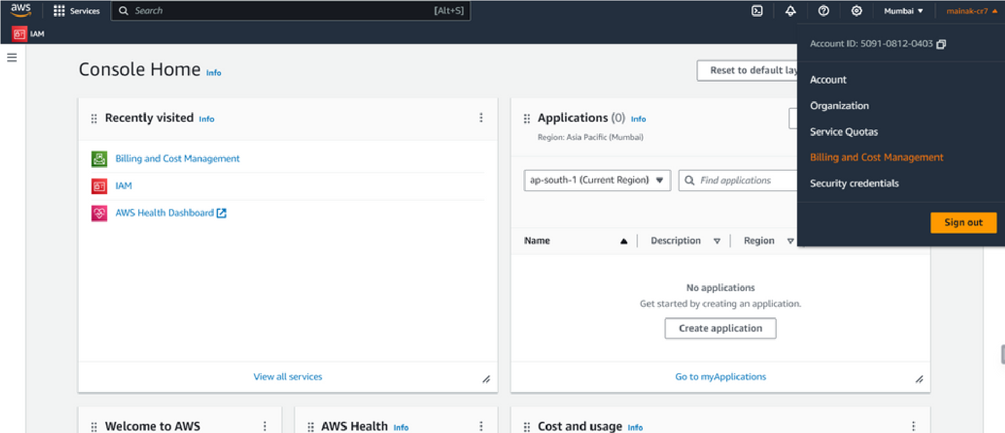

**Step 2.2:** Go to **Budgets** and then click on **Create Budget**

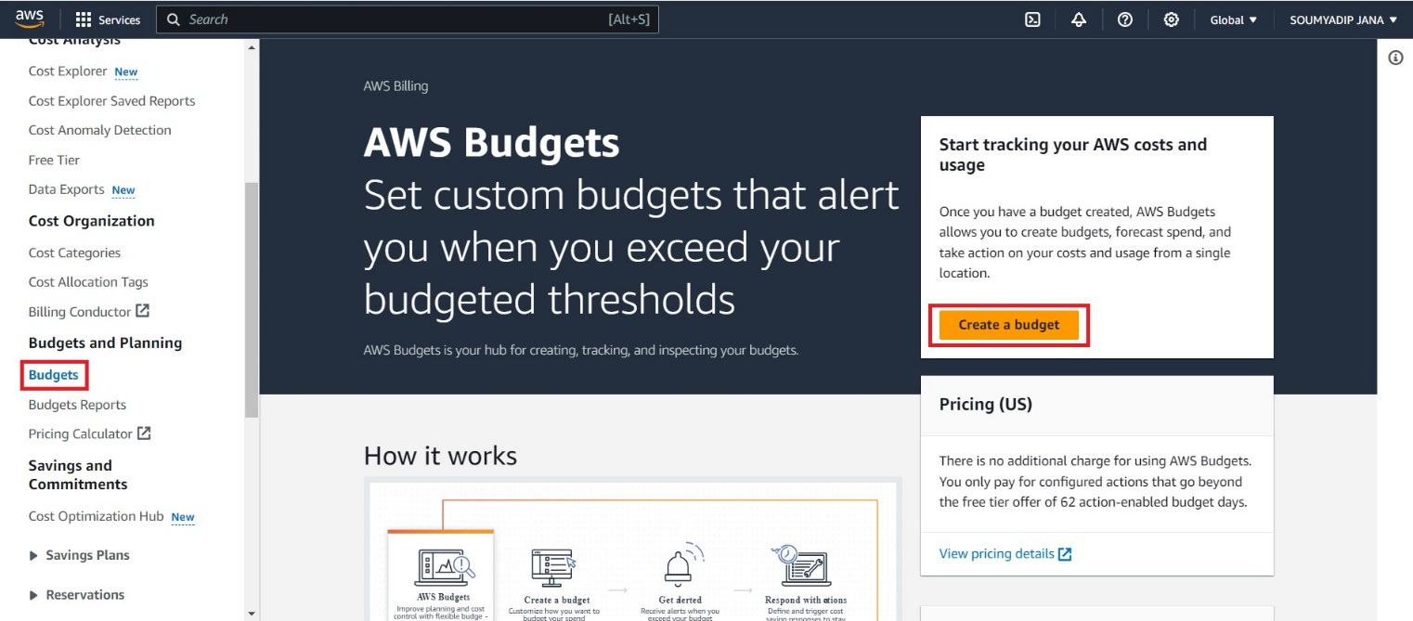

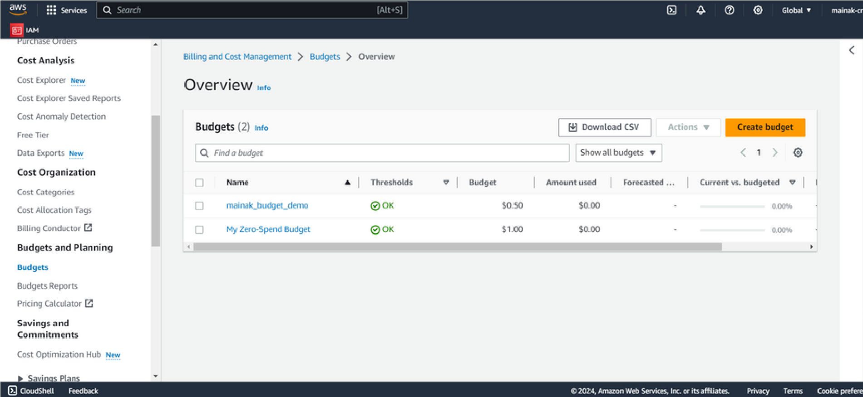

**Step 2.3:** Choose the **budget type**, you can use a **template** or **customize** it on your own to create a budget

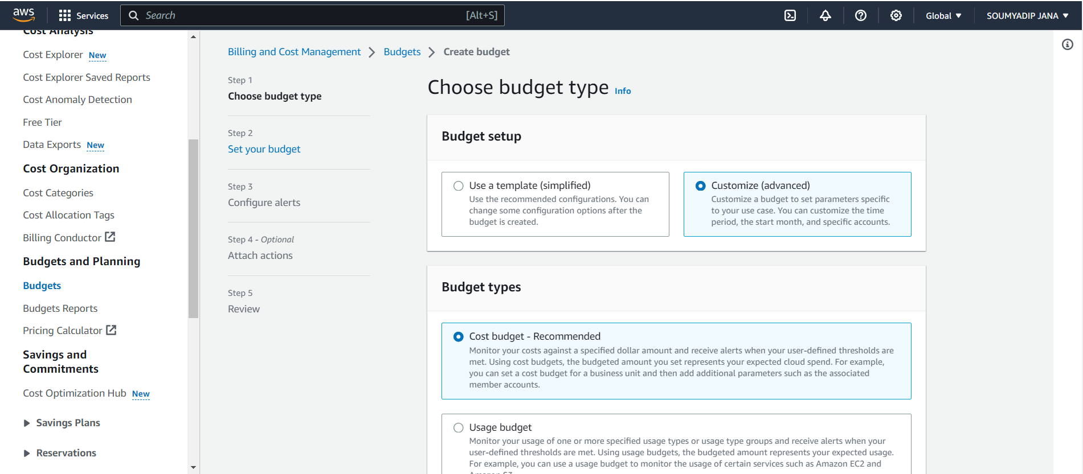

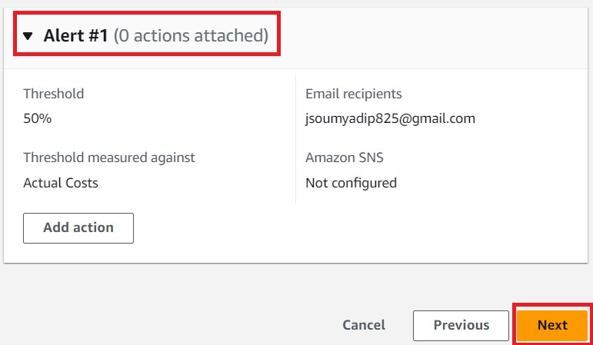**Step 2.4:** Choose the **budget name**, the **amount you can spend on the given budgeting period**, and the **email address(es)** where you are willing to get the **alerting emails.**  Then click on **Create Budget** to complete your budget creation.

